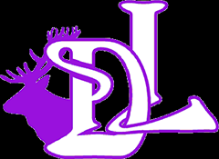Should I send my child into school today? – a Ditton Lodge Guide for Parents
.
Positive Test
- Your child must stay at home for 14 days from the onset of the positive person’s symptoms.
- NHS Test and Trace will inform you of next steps.
- You must inform the school as soon as possible.

If your child was not with you when you had contact with the positive person, then your child can attend school as long as you do not develop symptoms.
If you are contacted by NHS Test and Trace (and your child was with you during the contact with the Covid-19 person), you and your child must isolate for 14 days, even if you receive a negative test.
Negative Test
- Your child and family may stop isolating.
- Your child can return to school once they have been fever free for 48 hours.
Does a member of your household have symptoms of Covid-19?
- A new, continuous cough? (coughing for over an hour)
- A temperature? (over 38 degrees centigrade)
- A loss or change in taste or smell?

- All members of the household must stay at home.
- Any member of the household showing symptoms must get tested.
- Call NHS 111 or visit www.gov.uk/coronavirus and arrange for a test.

Your child can go to school.
NO
YES

