Ditton Lodge Primary School
Minutes of the virtual meeting of the Local Governing Body of Ditton Lodge Primary School on Tuesday 26th September 2023, 18:00 hours.
Present:  In attendance: Mrs Sheena Datson (Clerk) SD | Dr C Scarpini CS  Dr Anna Hardiman-McCartney AHM  Mrs Lisa King LK  Ms K Caley KC  Mrs A Bugg ABu | Mrs Amanda Banks ABa  Mrs Melanie Moore MM  Miss K Bramley KB  Mrs W McLaughlin WM

 | SECTION A: STANDARD BUSINESS
A1 | Welcome:  CS welcomed everyone to the meeting.
A2 | Election of Chair and Vice Chair: (this section was led by the Clerk)  CS was appointed Chair for another year. No Vice-Chair could be appointed. KC will support CS until a Vice-Chair is elected. Action: Defer to next meeting. SD to send Chair of Governors Role information to all governors.
A3 | Apologies for Absence accepted – ABe  Not present: none.
A4 | Pecuniary and Other Interests – none.
A5 | Focus for the meeting – Items all included in Information Report.  Confirm the documents/issues which governors wish to DISCUSS on for this meeting such as:  - Section 1 SEF/ADP – Evaluation and priorities for this year  - Section 2 SEND  - Section 3 Assessments/Outcomes  - Section 5 Staffing update  - Section 6 Student recruitment  - Section 7 Type 2 visits - to approve arrangements for type 2 visits include arrangements for monitoring  risk assessments
A6 | Minutes  The minutes of the meeting held on Tuesday 4th July 2023 were agreed.  Outstanding Actions: None.  Matters Arising: None.
A7 | AOB – Filtering and Monitoring.  P & C Item.
A8 | Annual Compliance  Completion of  - Declaration of Interests - complete  - USP Governors’ Code of Conduct - complete  - Confirmation that governors have received and read (at least) Section 2 of the most recent version of Keeping Children Safe in Education - complete  - Confirmation that governors have viewed the Unity SP Safeguarding Update Sept 2023- complete
A9 | Annual Governance Documentation  To note that the following documents from 2022/23 remain the same. These will be updated later in the term following the on-going DFE review.  - Scheme of Delegation 2022/23  - Handbook for Local Governance 2022/23
A10 | Training -The National College - General Safeguarding for Governors, GDPR and Cyber Security. To be completed by next meeting.  Useful information can be found on the USP in-house training programme via Governor Hub.  Also, the Unity SP Governors Resources and Information Page:  https://app.governorhub.com/s/uspnewsandinformation/news/64a69245aebbcc0ac606cffe
 | SECTION B: SCHOOL IMPROVEMENT
B1 | Information Report – Autumn 1 - Supporting documents on Gov Hub.  - LONG TERM VISION & CURRENT PRIORITIES  At Ditton Lodge Primary School, we: Listen; Enjoy and take risks; Aim high and achieve; Respect; Never give up.  Our Curriculum  The Ditton Lodge curriculum is designed to help everyone to have the knowledge they need to thrive and flourish in our 21st century global community. Throughout our curriculum the children will: Have a sense of belonging; Be ambitious to succeed; Continue on a learning journey; Experience the world beyond Ditton Lodge  See SDP 2023-24 Overarching Document in Governor Hub  - INCLUSION/SEND  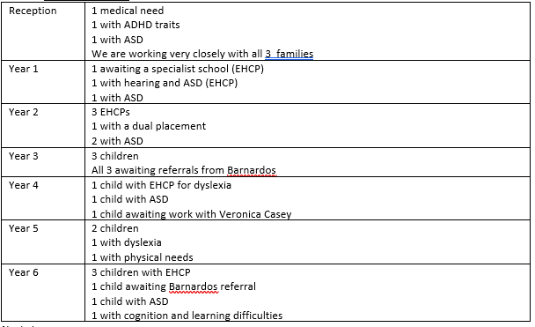  Next steps:  Awaiting Bells Croft training in October  Awaiting Incredible 5 Point scale training in November  We continue to work with Veronica Casey as our SEND link practitioner  We are well supported by George Ellis at the TRUST.  Links are strong with Cambs SEND team and are becoming stronger with Suffolk with our increase in Suffolk SEND children  - ASSESSMENTS/OUTCOMES  KS2 Data Comparison 2022-2023  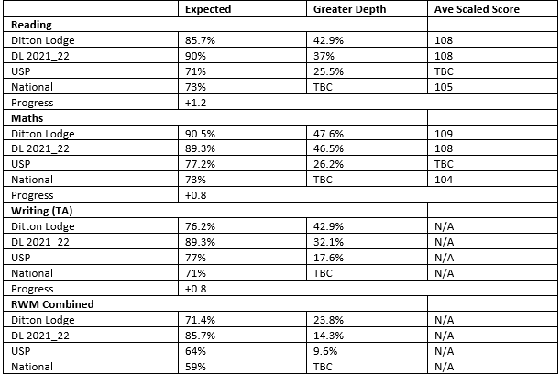  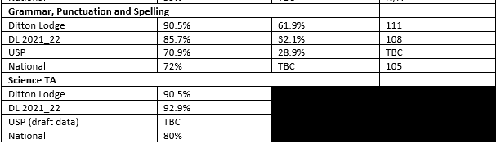  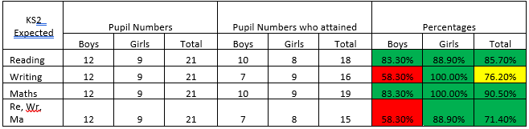  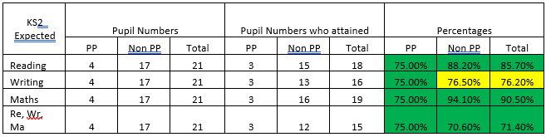  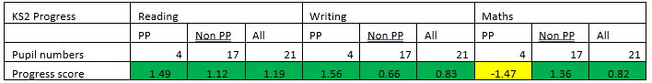  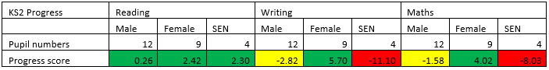  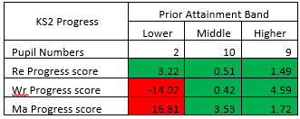  - BEHAVIOUR  There has been one suspension since our last LGB meeting.  We have one pupil on a dual placement at First Base in Bury (Alternative Provision) 3 days a week and Ditton Lodge 2 days a week. This is supporting him to remain at Ditton Lodge. We have booked a consultation meeting and Physical De-escalation training with BellsCroft Consultants who have previously carried out whole staff training on Behaviour and The Law.  - STAFFING UPDATE  One TA left at the end of the summer holidays to be able to home-school their children.  We have appointed: 1 part-time TA (7.5 hours a week); 1 Midday supervisor (6.25 hours a week); An existing TA (already working 27.5 hours a week) to a Cover Supervisor position; An existing TA’s hours have been increased by 12 hours to 22 hours a week.  - STUDENT RECRUITMENT  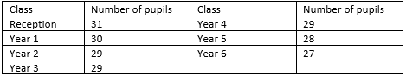  203 on roll as of Monday 18/9/23. 3 children waiting for confirmation of starting from Cambs which will make 206 on roll. Increase of 15 children from September 2022.  Open mornings/afternoons for new prospective parents set for: 08/11/23 AM; 15/11/3 PM; 20/11/23 AM  - ANY TYPE 2 TRIPS  Year 6 will be travelling to PGL Bawdsey Manor 18th to 20th October with VK, SP, ABr an AD. Approved by governors.  - SAFEGUARDING  All Staff have received Safeguarding and GDPR Training; All staff have read KCSiE 2023 part 1; All staff have read updated Safeguarding Policy and Child Protection Procedures 2023; We have one family who are CP; We have two families who have a family worker through EHAs; We have continued to support pupils and families through referrals to Early Help and  The Multi-agency Safeguarding Hub (MASH); Fire drill (19/9/23 and 8/11/23; Invacuation drill (10/10/23); CPOMs is used daily to share information or record concerns, although serious concerns are also reported verbally and immediately.  Vulnerable families continue to be supported though: Drop-in sessions with ELSA, SENDCO, Wellbeing lead and Family Worker; Liaison with professionals: Family workers working with specific families, Social Care and other agencies; School Holiday Vouchers for pupils in receipt of free school meals; Make Lunch meal support during school holidays; Regular communication with families: regular letters from the headteacher, regular communication from class teacher, welfare calls to any vulnerable family, regular updates on Google Classroom from class teachers and posts on X (formally Twitter).  Pupil wellbeing: Wellbeing Club; Therapeutic play Therapy for identified individuals; TA support for any identified pupil; Daily Management Plans with timetabled sensory breaks for specific pupils; Wellbeing activities; Individual predict and plan for identified pupils; ELSA support for specific pupils; Emotional Health and Wellbeing Service Cambs Professional Consultations.  Staff wellbeing: Kindness Fairies- staff have had the opportunity to sign up again as a kindness fairy. You are given a name and then look after secretly with notes, treats and acts of kindness; Wellbeing walks monthly (first one Sunday 24th September); Support from OM Health and wellbeing for staff including 1:1 sessions for staff; Employee assistance programme: Life Works; SAS wellbeing: App, phone support and counselling; Weekly Staff meeting; Weekly Staff briefing; Handbook on Padlet;  Family wellbeing: Updated information for parents from Emotional Health and Wellbeing Service; Wellbeing Newsletter; Bereavement support from ELSA; Access to Cambridgeshire Family Worker- Michelle West; Specific targeted support from family worker through Early Help Assessment referrals to both Cambs and Suffolk.  We currently have 3 DSL’s in school  - Mrs Moore (Refresher training booked for October)  - Miss Bramley (Refresher training booked for October)  - Mrs Datson
B2 | Data Report – See Information Report
B3 | Additional Governor Questions  Q: What involvement do Barnados have in SEND? A: To get a medical diagnosis such as ADHD or ASD, parents no longer go to their GP first but make an application to Barnardos (current waiting time 18 months).  Q: How is the funding used for EHCP children? A: Funds received do not adequately cover learning support. The school subsidises the cost of staff and other agencies, volunteers and trainee teachers are used in school to increase capacity across the school.  Q: Are we continuing with Governor Good News! A: Defer logistics to next meeting.
B4 | Safeguarding - See section 8 of Information Report.
B5 | Governor Monitoring Visits Report – nothing to report. Action: Dates to be suggested for this term.
 | REPORTS AND POLICIES
B6 | TRUST POLICIES  Safeguarding Policy and Online Safety Policy noted.
B7 | Information from The Trust  Chairs Briefing 25th September 2023. Items discussed included: attendance; increase in parental complaints across USP; new schools joining USP; i-Learning and digital CUSP.
B8 | School Policies -The Child Protection Policy was agreed.
 | SECTION C: FINANCE, HR AND PREMISES
C1 | Budget Information - Submitted budget for 2023_24 showed a deficit of -£5054.37. Staff changes since then have changed the balance to £771.  Year-end calculations currently show a deficit of -£29,000.00. the school started with a -£27,000 deficit. Teacher pay increases on top of budget were £27,000. In effect we saved £27,000 in year and overspent £2000.
C2 | Appraisal Process  Performance processes are scheduled. The Headtacher’s first appraisal of the year has taken place.
 | SECTION D: GOVERNING BODY ORGANISATION & ADMIN
D1 | GOVERNING BODY MEMBERSHIP – 1 vacancy for a Community Governor.
D2 | Governor Responsibilities and Monitoring Activities – All members part of all committees, Finance and Resources, Premises and H&S, Personnel.  Leads are as follows:  CS – Chair of LGB, E-Safety, EYFS, RE.  KC – Child Protection, Safeguarding, Well-being, Personnel,  LK – Children in Care (CIC), SEND, Finance.  AHM – Attendance, Monitoring and Filtering.  Performance Management:  CS and KC  Action: KC and AHM to meet with MM on 29th September 2023 ref safeguarding role.
D3 | Get Information about School (GIAS) - Confirmed by SD up to date.
D4 | Website Compliance – KB had done a lot of work to bring the website up to date and is to meet with SD this week to upload outstanding information.
D5 | Governor Monitoring, training and development – see A10.  - Annual Governors Conference Friday 13th October 2023. “Governance: Even Better if………..”  - Deadline for submitting Skills Audit and self-review end of September. All answers anonymised in feedback.
 | SECTION E: CLOSE OF BUSINESS
E1 | Impact  - Better than expected end of year financial outturn.  - Amazing data results from last academic year.  - Signify the fact that MM is not going to be here next term with grateful thanks for everything you have done for the school and the community. MM will be sorely missed. The LGB wish MM all the best for what comes next.  - The new academic year has started well.  - Exciting development of introducing iPads and iLearning in KS2.  - Amazing work with the SEND children, making sure they have the plans in place they deserve. “You are always on it”.
E2 | Questions/Items to be raised with the Trust – none.
E3 | AOB – Filtering and Monitoring. Every adult in school has a responsibility for the filtering and monitoring of all devices in school. No home devices are permitted for use in school. All devices are fitted with Smoothwall web filter/firewall. All children will access the Internet via a Smoothwall search engine. A new online safety policy is available on the USP website https://www.unitysp.co.uk/wp-content/uploads/2023/09/Online-Safety-Policy-2023.pdf  P & C Item recorded separately for LGB only.
E3 | Dates of future meetings – changed from Tuesday evenings to Monday evenings.  Autumn 2 04 12 2023 (f2f)  Spring 1 and 2 29 01 2024 (v) 18 03 2024 (f2f)  Summer 1 and 2 06 05 2024 (v) 01 07 2024 (f2f)
Mondays
CS thanked everyone for attending and closed the meeting at 20:04 hours.

