Ditton Lodge Primary School Child Protection Procedures
Date: September 2019 Next review due by September 2020
Our designated safeguarding staff

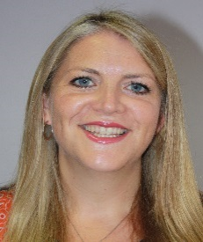 | 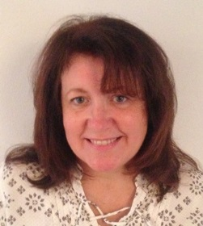 | 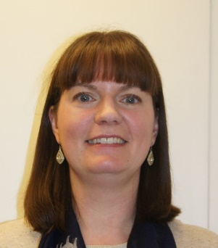 | 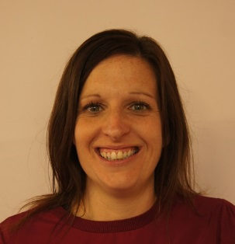
Mrs Melanie Moore | Mrs Sheena Datson | Miss Kim Bramley | Mrs Amanda Banks
Designated Safeguarding Lead (DSL) | Deputy DSL | Deputy DSL | Designated Teacher for Children in Care
mmoore@dittonlodgeprimary.co.uk | sdatson@dittonlodgeprimary.co.uk | kbramley@dittonlodgeprimary.co.uk | abanks@dittonlodgeprimary.co.uk
Mrs Melanie Moore | Ms Kath Caley | Dr Cinzia Scarpini | Mr Stephen Astley
Headteacher | Safeguarding Governor | Chair of the local governing body | Director of Education
mmoore@dittonlodgeprimary.co.uk | kcaley@dittonlodgeprimary.co.uk | cscarpini@dittonlodgeprimary.co.uk | sastley@unitysp.co.uk

Aim
- Schools and their staff form part of the wider safeguarding system for children. Everyone who comes into contact with children and their families and carers has a role to play in keeping them safe. To fulfil this responsibility effectively, all professionals must ensure their approach is child-centred. This means that they must always consider what is in the best interests of the child.
- These procedures are for all staff, parents, governors, volunteers and the wider school community. They form part of the safeguarding arrangements for our school. They should be read in conjunction with the trust’s policies on safeguarding, safer recruitment and selection, staff code of conduct, health and safety and acceptable use of ICT, and the school’s policies on behaviour (including the anti-bullying strategy and approach to physical intervention) and educational visits policy. They should also be read in conjunction with Keeping Children Safe in Education (Department for Education, September 2019). Safeguarding and promoting the welfare of children is defined in Keeping Children Safe in Education as:
  - protecting children from maltreatment
  - preventing impairment of children’s health or development
  - ensuring that children grow up in circumstances consistent with the provision of safe and effective care
  - taking action to enable all children to have the best outcomes
Expectations
- All staff and volunteers must sign to confirm they have read and agree to these procedures before the they start working with us. All children and their families will be provided with these procedures before enrolment. It is important for families to be aware of actions staff may take if there are any concerns for a child’s safety, and for them to understand that they might not be consulted before action is taken. Knowing about child protection procedures ahead of time helps parents to engage better in the process, meaning that change is more likely to take place.
- All adults working in our school who have contact with pupils are in positions of trust. Staff and volunteers should understand their responsibilities to safeguard and promote the welfare of pupils, including through early help. This means that staff and volunteers:
  - are responsible for their own actions and behaviour and must avoid any conduct which would lead any reasonable person to question their motivation or intentions
  - must work, and be seen to work, in an open and transparent way
  - must acknowledge that deliberately invented/malicious allegations are extremely rare and that all concerns should be reported and recorded
  - must discuss and/or take advice promptly from their line manager if they have acted in a way which may give rise to concern
  - must apply the same professional standards regardless of culture, disability, gender, language, racial origin, religious belief or sexual orientation
  - must not consume or be under the influence of alcohol or any substance, including prescribed medication, which may affect their ability to care for children
  - must be aware that breaches of the law and other professional guidelines could result in disciplinary action being taken against them, criminal action and/or other proceedings including barring by the Disclosure and Barring Service (DBS) from working in regulated activity, or for acts of serious misconduct prohibition from teaching by the Teaching Regulation Agency (TRA).
Early help
- Early help means providing support as soon as a problem emerges, at any point in a child’s life. Providing early help is more effective in promoting the welfare of children than reacting later.

- Ditton Lodge maintains an open door policy to meet and discuss with a member of the senior leadership team. Regular family worker drop in sessions take place and alternative sessions signposted at other venues. We work with our families to complete Early Help Assessments (EHA) to access external support and we can provide contact details for the school nurse and Cambridgeshire nursing team.
What to look out for (recognising children who are experiencing or at risk of harm)
- Children can be harmed in several ways; abuse can by physical, sexual, emotional or it can take the form of neglect (see Part 1 and Annex A of Keeping children safe in education (September 2019)). Children sometimes suffer more than one type of abuse at a time. Children as well as adults can be abusers; peer on peer abuse will never be tolerated or passed off as “banter”, “just having a laugh” or “part of growing up” (see Sexual violence and sexual harassment between children in schools and colleges). Protecting children from the risk of radicalisation is part of our wider safeguarding duties (see The prevent duty: for schools and childcare providers), and is similar in nature to protecting children from other forms of harm and abuse.
How to respond
- If you have a concern about a child’s wellbeing, based on:
  - something the child or their parent has told you
  - something another child has told you
  - something you have noticed about the child’s behaviour, health, or appearance
  - something another professional said or did
Pass all concerns immediately to the Designated Safeguarding Lead (DSL) or a Deputy DSL if they are not available.
- Even if you think your concern is minor, the Designated Safeguarding Lead (DSL) may have more information that, together with what you know, represents a more serious worry about a child. It is never your decision alone how to respond to concerns – but it is always your responsibility to share concerns, no matter how small.
  - Do not investigate but decide whether you need to clarify your concerns by asking the child or parent open questions (beginning with words like who, how, why, what, where and when) and being careful not to lead them. Do not discuss your concerns with the parent(s) if this may increase the risk to the child.
  - If you have heard a disclosure of abuse or are talking with a child or parent about your concerns, let them know what you will do next. For example, ‘I am worried about your bruise and I need to tell Mrs Smith so that she can help us think about how to keep you safe.’
  - Inform the DSL immediately. If the DSL is not available, inform a Deputy DSL. If none of the designated safeguarding staff or headteacher are available, you must make the referral yourself. Details of how to do this are at the end of these procedures.
  - As soon as possible after the event, make a written record using the recording form for safeguarding concerns or CPOMS. Recording forms are available on the Safeguarding Noticeboard in the staffroom or on Staffshare. If there was a disclosure, record the words of the child or parent rather than your interpretation. Include analysis of what you saw or heard and why it is a cause for concern.
- Any member of staff is entitled to report a safeguarding concern directly to the local authority if they do not feel able to refer the matter to the DSL. Details of how to do this are at the end of these procedures.
Who to pass concerns on to
- Names, photos and contact details for the DSL, Deputy DSL(s), Designated Teacher for Children in Care, Safeguarding Governor, Headteacher, Chair of the local governing body and relevant trust Director of Education are provided at the beginning of these procedures. Details of how to make a referral to the local authority are at the end.
Safeguarding concerns about another adult in the school
- Safeguarding concerns about another adult in the school must be referred to the Headteacher (or whoever is fulfilling the role in their absence), without delay. If the concerns are about the Headteacher they must be referred to the relevant trust Director of Education. They will contact the local authority Designated Officer (LADO) within one working day in respect of all cases in which it is alleged that a person who works with children has:
- Behaved in a way that has harmed a child, or may have harmed a child;
- Possibly committed a criminal offence against or related to a child; or
- Behaved towards a child or children in a way that indicates they may pose a risk of harm to children.
If you feel your concern has not been responded to appropriately, please contact the Trust Lead on Safeguarding (swatts@unitysp.co.uk)
Whistleblowing
- If you are concerned about poor or unsafe practice or potential failures in the school’s safeguarding regime, these should be raised with the Headteacher or the Chair of the local governing body, in the first instance. Please refer to the Trust’s whistleblowing policy.
- The NSPCC Whistleblowing Advice Line is available for those who do not feel able to raise concerns regarding child protection failures internally. You can call: 0800 028 0285. This line is available from 8:00 to 20:00, Monday to Friday or email: help@nspcc.org.uk.
Reviewing these procedures

- These procedures are reviewed at least annually and approved by the local governing body. Copies of these procedures and supporting materials, such as Keeping Children Safe in Education (Department for Education, September 2019), are available in the staffroom and on the school’s website. Hard copies may be requested from the school office.

Contact details for the local authority
- To seek advice before making a referral to the local authority referral centre contact:
Cambridgeshire – 03450455203 referralcentre.children@cambridgeshire.gov.uk
Emergency Duty Team (out of hours) 01733234724
Suffolk - Professional Consultation Line 03456061499

- To make a referral to the local authority contact MASH:
Cambridgeshire - 03450451362 NASG.C&F@cambridgeshire.gcsx.gov.uk
Suffolk - 03456-61499 click link below for online referral form https://earlyhelpportal.suffolk.gov.uk/web/portal/pages/marf#h1

