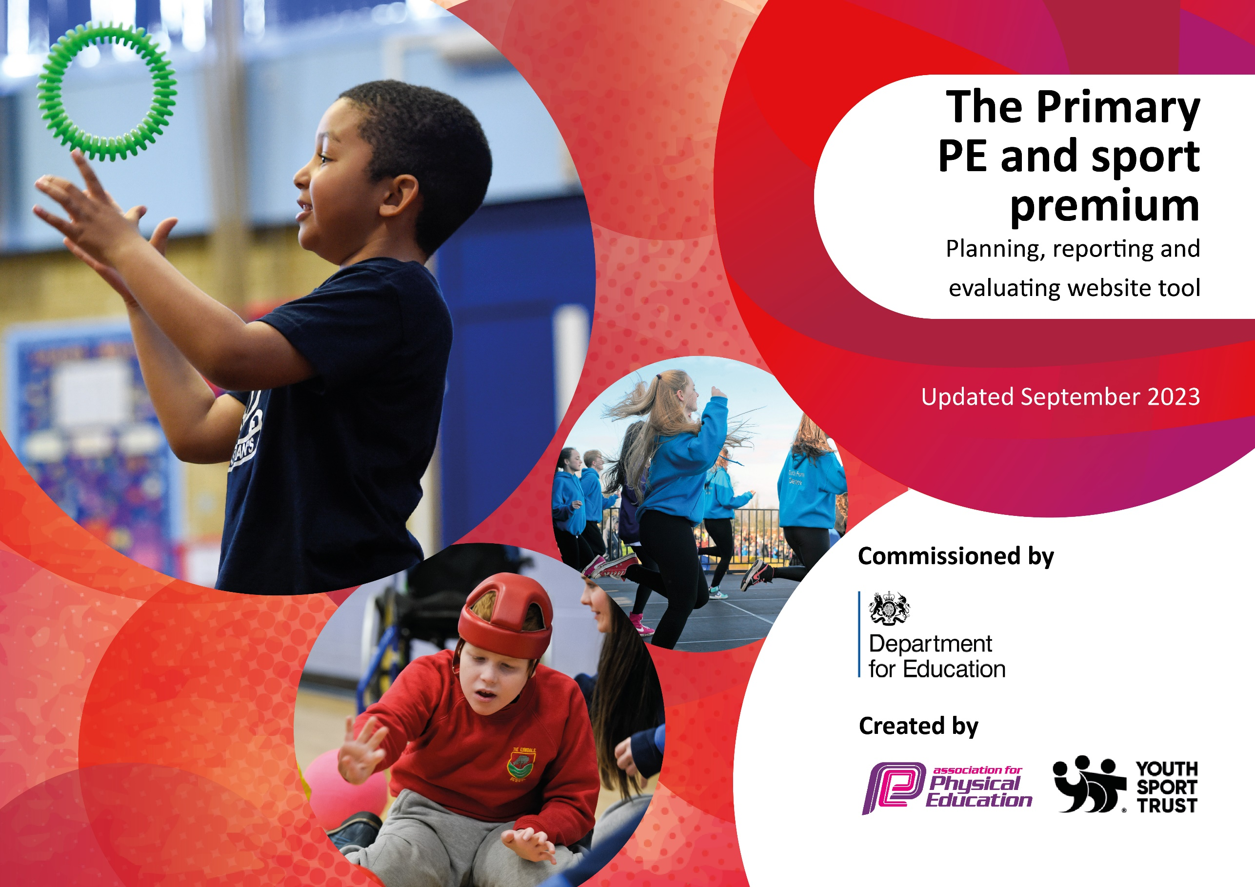

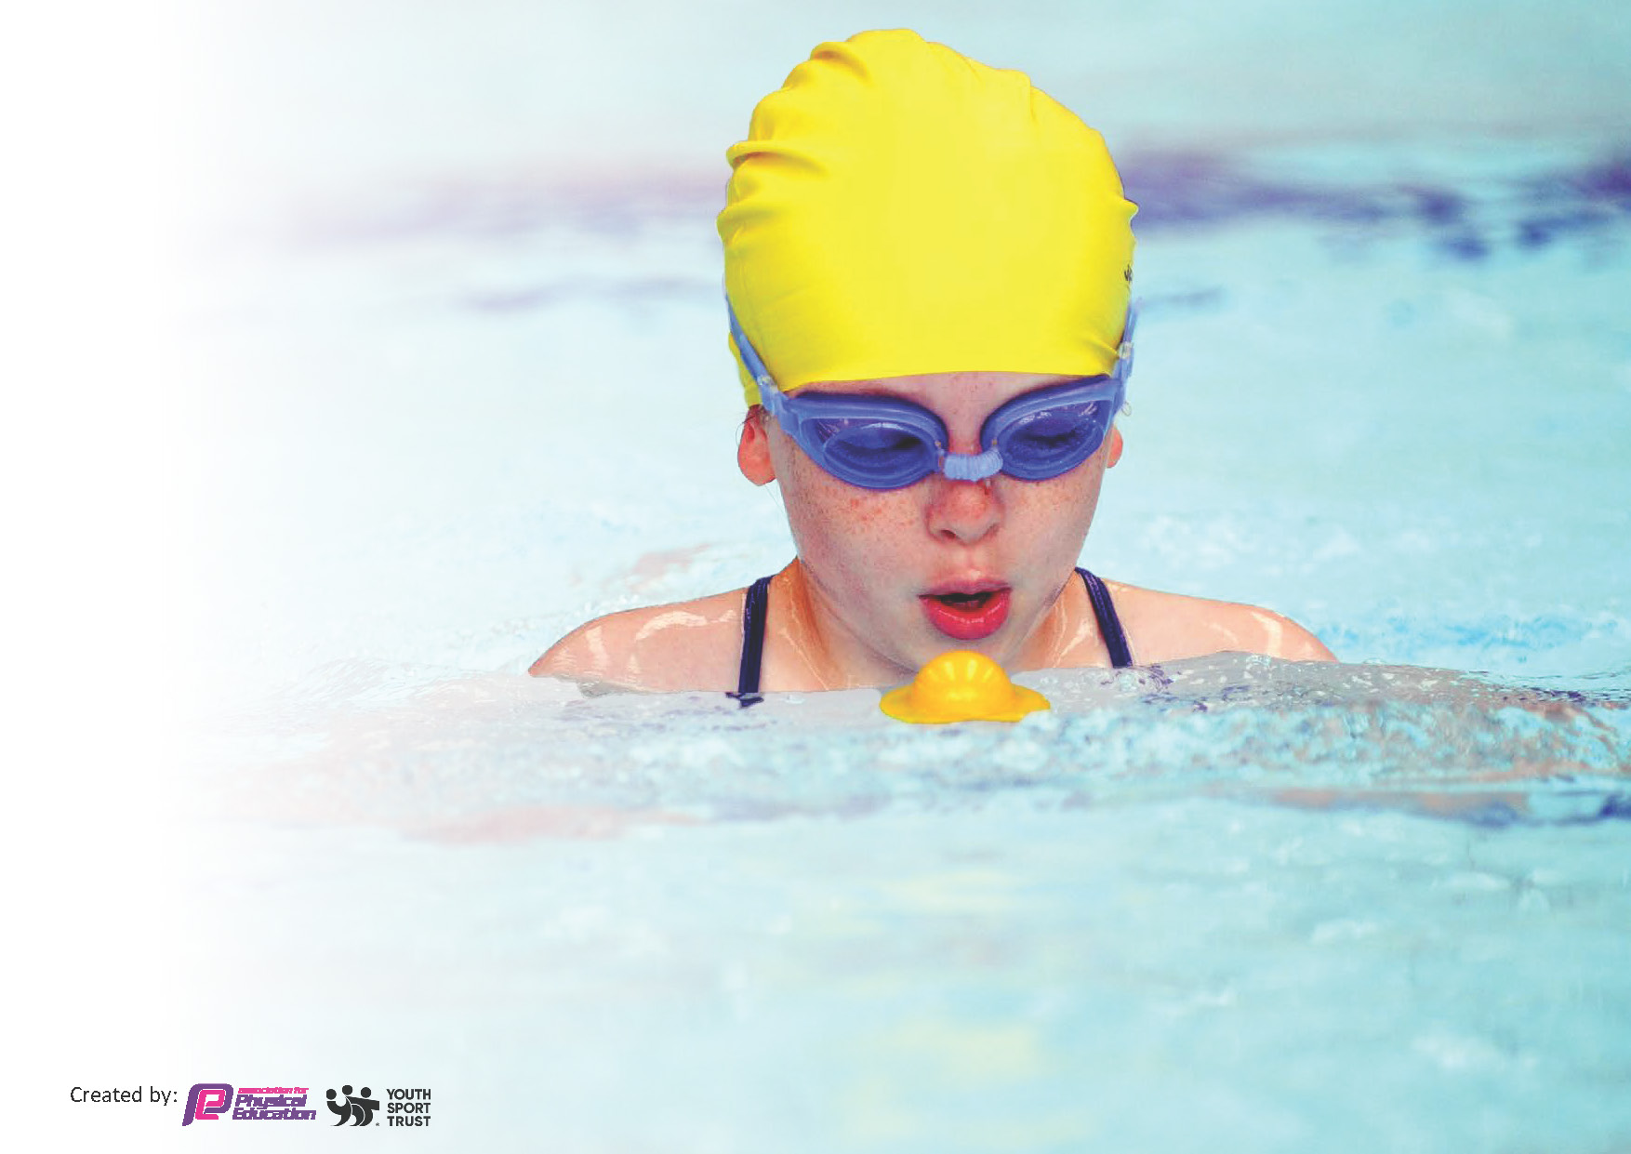
This template can be used for multiple purposes:
by:
- It enables schools to effectively plan their use of the Primary PE and sport premium
- It helps schools to meet the requirements (as set out in guidance) to publish information on their Primary PE and sport premium
- It will be an effective document to support Ofsted inspections enabling schools to evidence progress in Physical Education (PE) and evidence swimming attainment, which forms part of the PE National Curriculum. We would recommend schools consider
the Intent, Implementation and Impact of any spend, as examined within the Education Inspection Framework.

It is important that your grant is used effectively and based on school need.

Schools must use the funding to make additional and sustainable
improvements to the quality of the PE, School Sport and Physical Activity (PESSPA)
they offer. This means that you should use the Primary PE and sport premium to:

- Build capacity and capability within the school to ensure that improvements made now will benefit pupils joining the school in future years
- Develop or add to the PESSPA activities that your school already offers.

The Primary PE and sport premium should not be used to fund capital spend projects; the school’s core budget should fund these. Further detail on capital expenditure can be found in the updated Primary PE and sport premium guidance.

The Primary PE and sport premium guidance, outlines 5 key priorities that funding should be used towards. It is not

necessary that spending has to meet all the key priorities, you should select the priorities that you aim to use any funding towards.

Although completing this template is not a requirement for schools, schools are required to publish details of how they spend this funding. Schools must also outline what the impact this funding has had on pupils’ PE and sport participation and attainment and how any spending will be sustainable in the future. All funding must be spent by 31st July 2024.

The Department for Education has worked closely with the Association for Physical Education (afPE) and the Youth Sport Trust (YST) to develop this template and encourages schools to use it. This template is an effective way of meeting the reporting requirements of the Primary PE and sport premium.
Review of last year’s spend and key achievements (2023/24)

We recommend you start by reflecting on the impact of current provision and reviewing your previous spend.

Activity/Action | Impact | Comments
Key indicator 1: The engagement of all pupils in regular physical activity – Chief Medical Officers guidelines recommend that primary school pupils undertake at least 30 minutes of physical activity a day in school | -A variety of clubs have been provided for children at lunch times and after school. Sports such a rounders, athletics, basketball, hula hoops and football are examples. Children received these provisions each week.  -Outside agencies such as Premier sports delivering after school clubs  -This continues to be implemented successfully. -Teachers use scheme to deliver lessons weekly.  -All classes in the school have taken part in a variety of new opportunities.  - Bikeability expanded to Years 3 and 4 students as well as yr5 and 6 – all pupils achieved.  -EYFS have completed the 6 week balance ability course during the summer term.  -Children have experienced many enrichment days. -Abbey Croft has provided 2 activity days for the whole school to take part in archery, orienteering and climbing.  -Daily mile relaunched where children can run or jog for 15 minutes a day at their own pace in the fresh air, on their own or with friends, most children average a mile or more in this time each day. Extra/additional clubs to meet interest of children who don’t favour traditional sports. - Play Leaders used to increase activity during lunchtimes.  - Funding used for families in difficult circumstances (e.g. pupils eligible for free school meals) to attend clubs run by external providers.  As a school we have taken part in multiple competitions and festivals.  -We have completed a whole school virtual cross country and virtual dance festival. KS2 have had multiple opportunities to take part in sports events. For example Multi sports festival, rugby skills festival, football competition U11 girls, Quadkids athletics.  -Premier sport have been in once a week every term to provide sporting opportunities for children in the school. They have ran a variety of clubs such as tennis and gymnastics  -Year 6 camp residential at the end of the Summer | -Children active throughout school day and after school.  -GetSet4PE provide plans for all teachers, especially those with less confidence/ experience. Teachers feel more confident in ability to teach PE.  -This has provided children an opportunity to try something new.  -EYFS developed agility, balance and coordination skills during this course.  -Children have engaged in all activity days well and for some experienced something new.  -Children have taken part in a variety of sports, it has encouraged participation in a variety of sports. It has built children confidence and communication skills.  -Children have received fun, engaging after school activities which build their confidence, fitness and communication skills.
Key indicator 2: The profile of PESSPA being raised across the school as a tool for whole school improvement | -During mental health week in February children took part in a range of physical activities. All children took part in a yoga workshop.  -EYFS have completed the 6 week balanceability course during the summer term.  -Year 6 completed bikeability course during the Spring term.  Reception Class improvement of outside learning area Purchased additional resources/equipment to enrich curricular provision.  -Forest School sessions started at the end of the Year Sessions were lead by a specialist.  -2 minutes challenges in each class. Each class running fortnightly personal challenge boards aimed to push personal bests in new activities.  -Year 6 football competition with a local primary school.  The whole school completed a virtual cross country challenge during Autumn term.  -PE lead was been given some release time. | -Children have engaged well completed fun ways to get more active.  -EYFS developed agility, balance and coordination skills during this course.  -Bikeability builds life skills and develops children confidence on the roads.  -They learn about road safety.  -Children were enthusiastic and engaged to improve and push themselves.
Key indicator 3: Increased confidence, knowledge and skills of all staff in teaching PE and sport | -PE lead attended training within membership (physical literacy workshop and networking day) Staff meeting to be delivered in Autumn term.  -PE lead has given some time to do learning walks and observations. Feedback given to teachers after observations. | -PE lead sharing knowledge in staff meeting. Looking at how physical literacy is an important part of a childs development.  -PE lead sharing what a good PE looks like and what to include, ensuring consistency within school using Getset4PE scheme.  -PE lead and teachers working together to improve aspects of PE.
Key indicator 4: Broader experience of a range of sports and activities offered to all pupils | -There have been a wide range of clubs available for all year groups. Teachers deliver lunchtime PE clubs such as hula hoops, basketball, football, games and skipping.  -We had a football whole school assembly and whole school workshop in June.  -EYFS have completed the 6 week balanceability course during the summer term.  -Year 6 completed their bikeability course.  -Time given to subject leader to organise opportunities for children to be active regularly. | -Children have clubs available to choose from.  -Children were excited, engaged and enthusiastic to hear about real life examples and see inspirational sports people.  -EYFS developed agility, balance and coordination skills during this course.  -Bikeabilty builds life skills and develops children confidence on the roads. They learn about road safety.
Key indicator 5: Increased participation in competitive sport | -Ian Jackson has planned and delivered a variety of competitions. As a school we have taken part in multiple competitions and festivals. We have completed a whole school virtual cross country and virtual dance festival. KS2 have had multiple opportunities to take part in sports events. For example, Multi sports festival, rugby skills festival and indoor athletics. They have also taken part in U11 cross country competition. KS2 have been to the competitions over the academic year.  -Sports day held in July. Sports day modified to make more competitive. - | -Children have participated in a range of competitions and festivals, increasing their confidence. They have competing and worked alongside other schools/ children increasing their communication skill  -Children enjoying taking part in a variety of events. Belong, develop and compete strands of competition have challenged the children.  -Competitive sports day where children took part in a variety of activities. They won medals and stickers. Children were motivated by these.

This planning template will allow schools to accurately plan their spending.
Key priorities and planning 2045-25

Action – what are you planning to do | Who does this action impact? | Key indicator to meet | Impacts and how sustainability will be achieved? | Cost linked to the action
Forest School sessions for all year groups (linked to CUSP learning) | All of the pupils of Ditton Lodge as well as the skills and CPD for staff. | Key indicator 1  Key Indicator 3 | More pupils in our school achieving their personal physical goals and being more active whilst at school.  Team work, problem-solving and ethic linked to speaking and acting alongside other children. These skills will then transfer to team games. | £2990 a term (£8,970 a year)

Action – what are you planning to do | Who does this action impact? | Key indicator to meet | Impacts and how sustainability will be achieved? | Cost linked to the action
Sports Clubs at lunchtimes | All children at Ditton Lodge | Key Indicator 1  Key Indicator 3  Key Indicator 4  Key Indicator 5 | All staff to lead clubs that engage and lead to the children being adding to their active goals during school. Opportunity to try new things.  Improved skills ranging from dance to football.  This will lead to further and more successful outcomes in tournaments and inter-school events.

Action – what are you planning to do | Who does this action impact? | Key indicator to meet | Impacts and how sustainability will be achieved? | Cost linked to the action
Sports Competitions | Children that try out and are selected for teams.  A number of the events that are held locally involve whole year groups or whole classes  Set competitions across 3 schools and led intra school by Adam Dellar | Key Indicator 3  Key Indicator 4  Key Indicator 5 | All children that try out or take part will have the opportunity to experience competitive sport and representing your school.  Children grow in confidence to take part in sports outside of school and join other teams and clubs.

Action – what are you planning to do | Who does this action impact? | Key indicator to meet | Impacts and how sustainability will be achieved? | Cost linked to the action
Tuesday Enrichment | All children at Houldsworth Valley | Key Indicator 4 | All children offered to attend a club on Tuesdays until 4pm – this is inclusive to ALL pupils.  A range of sports clubs ranging from Running to tennis. Also using the forest school and the skills grown in Abbeycroft sessions.

Action – what are you planning to do | Who does this action impact? | Key indicator to meet | Impacts and how sustainability will be achieved? | Cost linked to the action
Workshops, Sports Days and Special Events | All children at Ditton Lodge | Key Indicator 4 | Children to take part in workshops as in previous years. For example: Skateboarding, football skills, Abbeycroft climbing wall days, archery, yoga and maypole dancing. | £2000

Action – what are you planning to do | Who does this action impact? | Key indicator to meet | Impacts and how sustainability will be achieved? | Cost linked to the action
Get, Set, P.E CPD  Release subject leader to team teach and monitor excellence in this area | Staff of Houldsworth Valley  Pupils of Houldsworth Valley | Key Indicator 3 | Staff to receive CPD in staff meeting time.  P.E. leader to attend local sports partnership meetings as well as Unity Trust CPD. | £500  £1000
To be part of the Newmarket Sports Partnership -including access to CPD and competition  To complete balance and bikeability through this. | All pupils | Key Indicator 1,2,3,4,5 | Competitions attended and staff upskilled during release time/staff meeting time | £1200  £1000

Key achievements 2024-25
This template will be completed at the end of the academic year and will showcase the key achievements schools have made with their Primary PE and sport premium spending.

Activity/Action | Impact | Comments

Swimming Data
Meeting National Curriculum requirements for swimming and water safety.
Priority should always be given to ensuring that pupils can perform safe self-rescue even if they do not fully meet the first two requirements of the National Curriculum programme of study

Question | Stats: | Further context  Relative to local challenges
What percentage of your current Year 6 cohort can swim competently, confidently and proficiently over a distance of at least 25 metres? | 70% | Use this text box to give further context behind the percentage.  e.g., 30% - we are struggling to get pool space due to our local pool closing so we have had to use a much smaller local school pool. We have had to limit the number of pupils attending swimming lessons during one term which means some pupils have attended fewer swimming lessons than others.
What percentage of your current Year 6 cohort can use a range of strokes effectively [for example, front crawl, backstroke, and breaststroke]? | 70% | Use this text box to give further context behind the percentage.  e.g., Even though your pupils may swim in another year please report on their attainment on leaving primary school at the end of the summer term 2024

What percentage of your current Year 6 cohort are able to perform safe self-rescue in different water-based situations? | 70% | Use this text box to give further context behind the percentage.
If your schools swimming data is below national expectation, you can choose to use the Primary PE and sport premium to provide additional top-up sessions for those pupils that did not meet National Curriculum  requirements after the completion of core lessons. Have you done this? | Yes

Signed off by:

Head of School | Lisa Tweed
Subject Leader or the individual responsible for the Primary PE and sport premium: | Rachel Hogg  Sarah Eaton
Date: | 24.10.24

